American Bar Association

Section of Dispute Resolution

Civil Collaborative Law Symposium
Bringing Healing to Law and Medicine
April 7, 2010 l Hyatt Regency Embarcadero l San Francisco, CA

Co-sponsored by: ABA Tort Trial and Insurance Practice Section & ABA Health Law Section

Symposium Chair: Kathleen Clark, PhD, JD, MAM
KathleenClark@ServantLawyership.com
www.ServantLawyership.com
This symposium aims to create an environment for interested professionals to come together to share ideas, rethink processes and practices, and enhance learning regarding collaborative practices, focusing on health care/adverse medical events; collaboration across professions; and exploration of other arenas and successes in the use of collaborative law practices.

8:30am
Opening Plenary:
Sandy Coletta, James Woods, and Mark Decof are proof of the transformative power of collaborative dialogue, disclosure, sincere apology, and compensation after medical error. Mr. Woods and Ms. Coletta agreed to settle a medical malpractice suit brought after Mr. Woods’ younger 49-year old brother died at Kent Hospital. Ms. Coletta reached out to James Woods and Mark Decof, asking to meet face to face with Mr. Woods over dinner after previous efforts to settle had failed. With Mr. Woods’ and his family’s support, the hospital has committed to create The Michael J. Woods Institute at Kent Hospital to focus on redesigning healthcare systems using a human centered approach to improve clinical outcomes. The moving video news clip features Ms. Coletta and Mr. Woods in their own words. http://tinyurl.com/woodslawsuit
Panelists:
- Sandra Coletta, MBA, CEO, Kent Hospital, Warwick, Rhode Island
- Mark Decof, attorney, Decof & Decof, Providence, Rhode Island
- Actor James Woods, Providence, Rhode Island

10:00am
Collaborative Law/Practices in Adverse Medical Event Situations
Panelists:
- Mark Graber, MD, Chief of Medicine of Northport NY VA Medical Center
- June Riley, Executive Director of Physicians Reimbursement Fund, San Francisco, CA
- Kathleen Clark, attorney, founder/ CEO, Servant Lawyership, Pleasant Hill, CA
- Ila Rothschild, Special Counsel to the Joint Commission, Chicago, IL

11:30am
Civil Collaborative Law and its Successes in Other Arenas:
Probate and Estates, Business Disputes (including family-owned businesses), and Employment Disputes
Panelists
- Bill Andrews, attorney, Santa Rosa, CA
- Jeanne Fahey, attorney, Oakland, CA
- Claire Spector, NY attorney, Santa Rosa, CA

12:30pm
Keynote Luncheon
Kathy Bryan, JD, President & CEO, International Institute for Conflict
Prevention and Resolution (CPR Institute), New York, NY
2:00pm
Afternoon Session and Small Group Breakouts:
After a demonstration, a three-hour hypothetical with an adverse medical event factual situation and small group work doing a collaborative case.
Facilitators:
- Sherrie Abney, attorney, Dallas, TX
- Kathleen Clark, attorney, Pleasant Hill, CA
- Larry Maxwell, attorney, Dallas, TX
- Ruth Rickard, attorney, Dallas, TX
- Claire Spector, attorney, Santa Rosa, CA

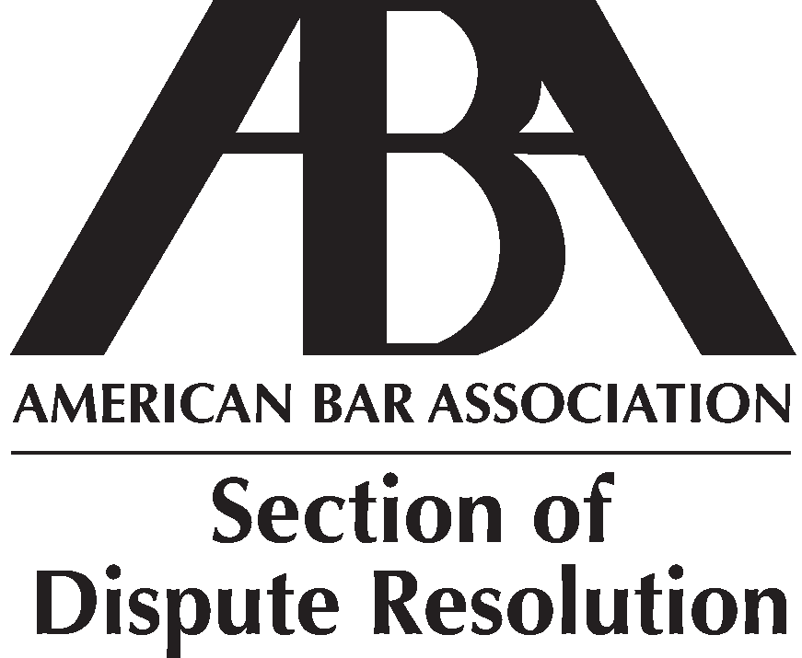
Registration
Registration: $125 for attendees of the ABA Dispute Resolution Section Spring Conference; $195 all others.
Registration includes program materials, light breakfast, and the luncheon.

CLE Credit will be applied for.
www.abanet.org/dispute

